E3: Linear Interpolation (LERP)

Course: IGME 309 – Real Time Simulations for Games II

Golisano College of Computing and Information Sciences

School of Interactive Games and Media

Rochester Institute of Technology

Due: Check in MyCourses

Deliverable: AppClass.cpp file (single file, unzipped)

**Objective:**

The goal of this exercise is to implement a Linear Interpolation (LERP) algorithm. Students will modify the provided solution to make the triangle bounce off the screen borders.

**Instructions:**

This exercise follows lecture D03

1. In the root of the repository look for the solution file and open it in the most current version of visual studio, if while opening it, it asks to update your file to a newer version of the SDK, do so.

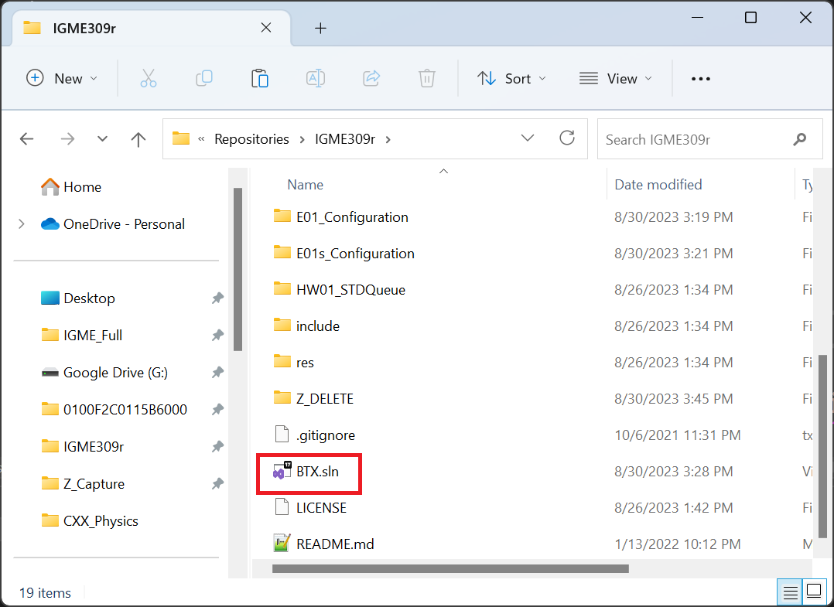

1. Once your solution is open make sure you right-click on the LERP exercise and set it as your start project.

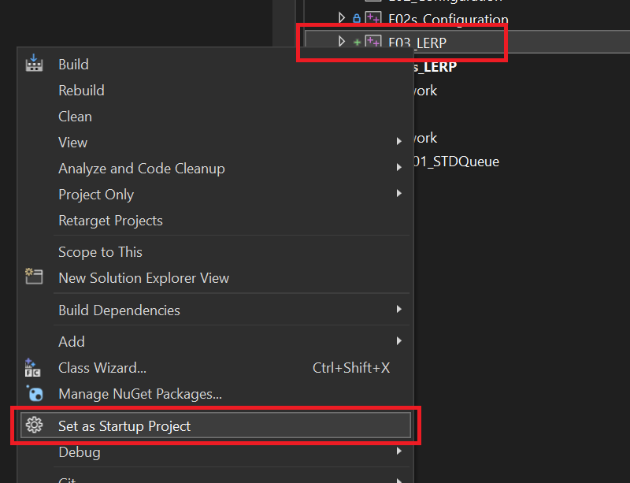

1. Open the file AppClass.cpp and look for the update method, this is the only file you will need to modify.

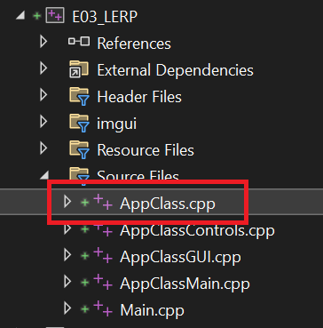

1. In the Update method you will find a section that needs to be updated, all your code goes here

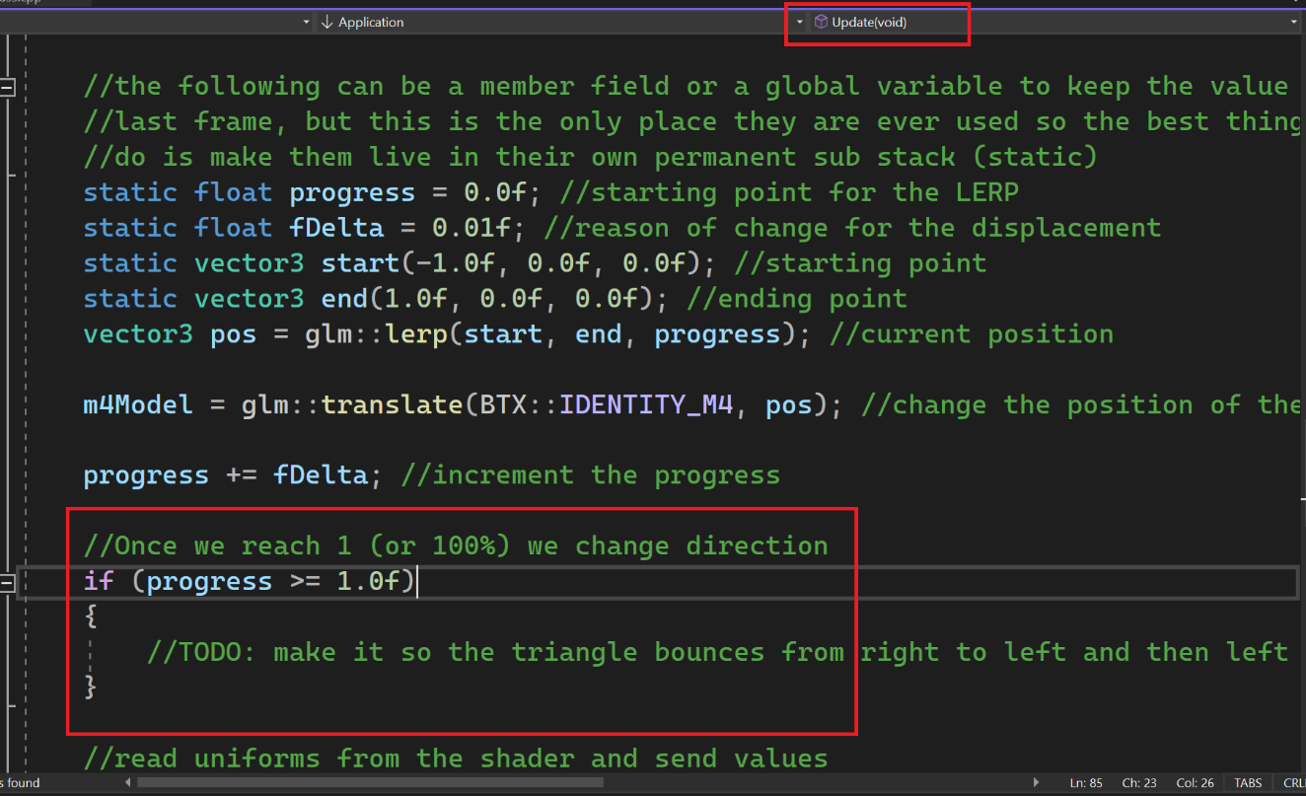

1. Out of the box the code will display a triangle in colors that will move left to right, what you are meant to do is modify the code in such a way that the triangle bounces from the border of the screen once it reaches it.

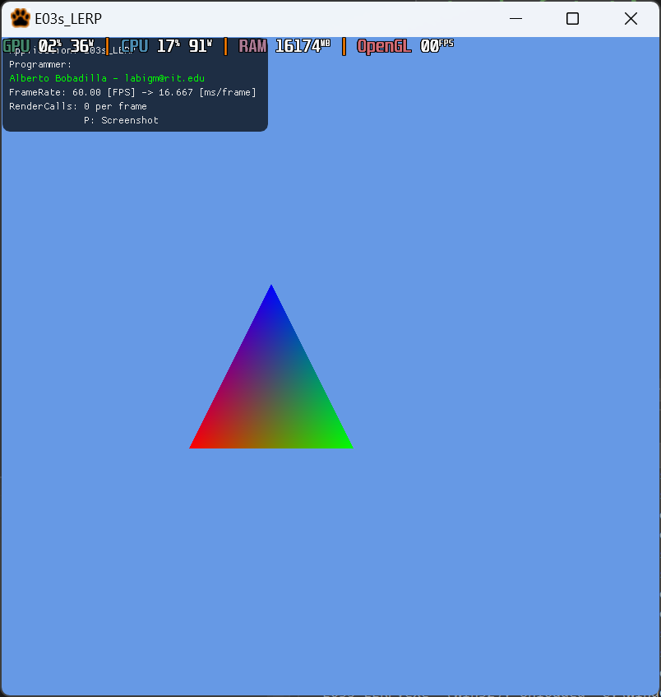

You may take a look at the solution file under the _Binary folder to make things clearer.

1. For this submission the only file we need to grade you is the AppClass.cpp file, this is because you have no need of modifying any other file on the solution (like the vcxproj or other h or cpp files). Other submissions will ask you for a full project zip (as was the case of the last exercise) so always be on the lookout of what is expected of your submission. Do not forget to push to your repository, just in case.

